Electrochemistry

Question 1

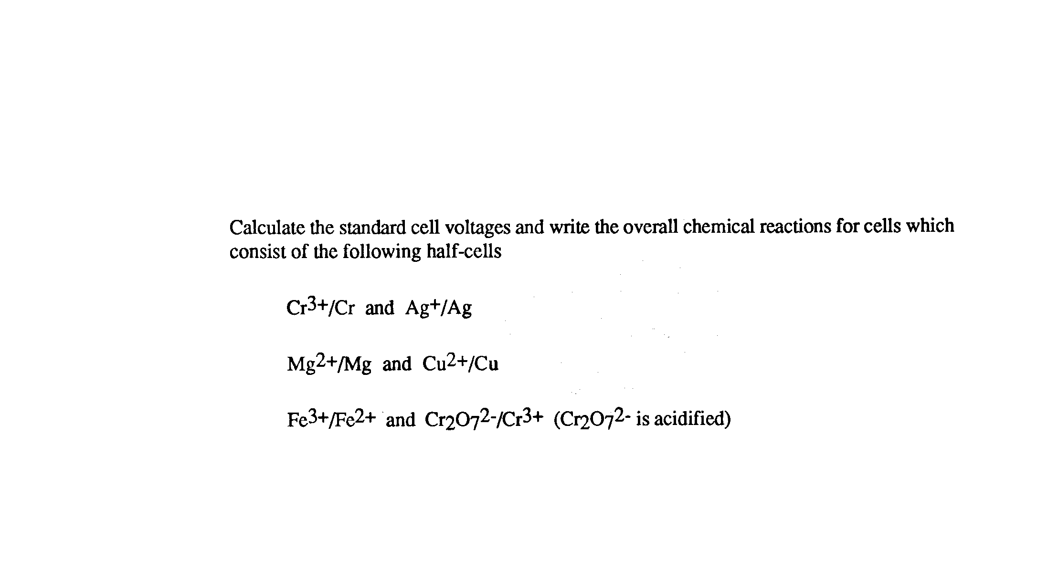
(a)

(b)

(c)

Question 2

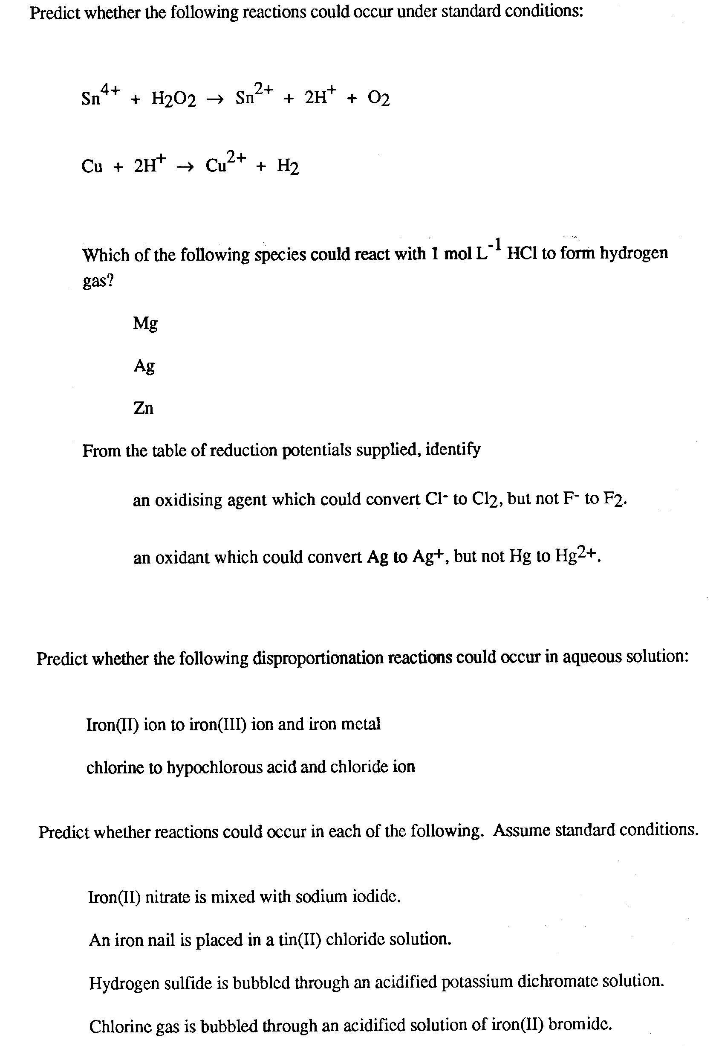
(a)

(b)

Question 3

(a)

(b)

(c)

Question 4

(a)

(b)

Question 5

(a)

(b)

Question 6

(a)

(b)

(c)

(d)

